Chapter 9: Building the regression model I: model selection and validation

Goal: Find the most parsimonious model that best estimates the response variable.

Tools: t-test, overall F-test, partial F-test, R², 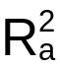, diagnostic measures, …

9.1 Overview of the model-building process

- Data collection and preparation
- Reduction of predictor variables
- Model refinement and selection
- Model validation

See Figure 9.1 on p. 328

- Data collection and preparation

See the discussion on different types of studies (controlled, controlled with additional predictor variables, confirmatory observation studies, and exploratory observational studies).

Note that the NBA guard performance example is an exploratory observational study.

After data is collected, one should do “edit checks” to make sure no extreme data entry errors are made. For example, we used box and dot plots for the predictor variables and the response variable in the NBA guard data set back in Chapter 6.

- Reduction of predictor variables

Often, there are a large number of predictor variables under consideration. Since we want the most parsimonious model, it is important to remove predictor variables that may not be important to predicting the response variable.

In addition, if prior knowledge of the data suggests that interaction and quadratic terms are important, these should be included in this step.

- Model refinement and selection

Determine if interactions and curvature effects are needed in the model. Diagnostic checks can be helpful to determine if changes need to be made to the model because of model assumption violations. For example, examine the constant error variance and normality assumptions and make changes to the model as needed.

- Model validation

Section 9.6 discusses this in detail.

9.2 Surgical unit example

Read!

9.3 Criteria for model selection

Let P-1 = the total number of predictor variables under consideration.

Let p-1 = number of predictor variables in a model under consideration.

We will just consider models and their first-order terms for now.

Examine ALL possible regression models to determine a set of models that are “good” to consider further.

Suppose there are the predictor variables X₁, X₂, and X₃. ALL possible models include the models of: no predictor variables, X₁ only, X₂ only, X₃ only, X₁ and X₂, X₁ and X₃, X₂ and X₃, and X₁ X₂ and X₃.

Note:
  - No transformations or interactions are considered at this stage of the model building process (unless they are believed to be important based on knowledge of the data set).
  - The number of possible models is 2^{P-1}

There are a variety of different criterions that can be examined to determine which models are “good”.

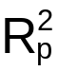 or SSE_{p} criterion

is the coefficient of determination. The subscript p denotes the p-1 variables (p β parameters) in the model for which R² is calculated. Models with a “large” are considered “good”.

SSE_{p} is the sum of squared errors. The subscript p denotes the p-1 variables in the model for which SSE is calculated. Models with a “small” SSE_{p} are considered “good”.

Notes:
- There is an equivalence between examining these two measures since 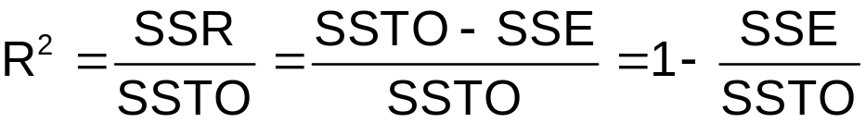
and SSTO will not change due to the same response variable being used for each model.
- Remember that R² always increases (or stays the same) as variables are added to the model. Because of this, one should look for a point where the starts to level off as more predictor variables are added to the model. A similar discussion can be made about SSE_{p}. For example, a plot like the following could be constructed:
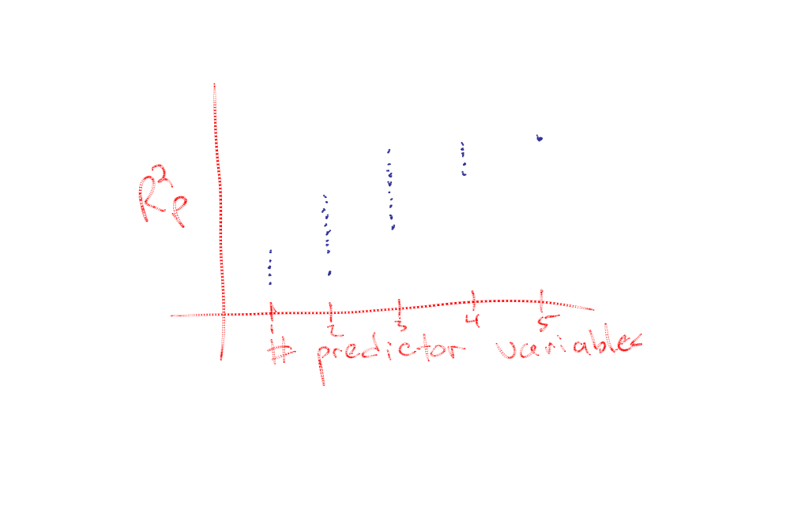
Each point on the plot represents an R² for a particular model. In this plot, we see the highest 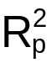 values level off starting at 3 predictor variables (p = 4). Thus, the “best” model for this criterion is the model with highest point for 3 predictor variables.

MSE_{p} or 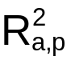

Since never decreases, (equivalently MSE) can be used instead.

Note that
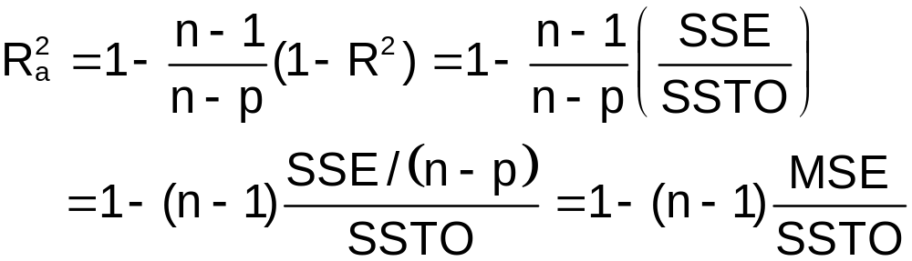

What would correspond to the best model according to this criterion?

Mallow’s C_{p} criterion

Steps:
- Compute MSE(X₁,…,X_{P-1}). This serves as the “best” estimate of σ².
- Compute SSE(X₁,…,X_{p-1}) for each subset model
- Note that IF MSE(X₁,…,X_{p-1})=SSE(X₁,…,X_{p-1})/(n-p) is about the same as MSE(X₁,…,X_{P-1}), then

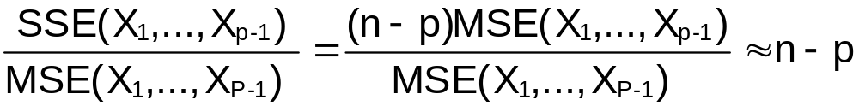

where ≈ means “approximately”.

- Compute:
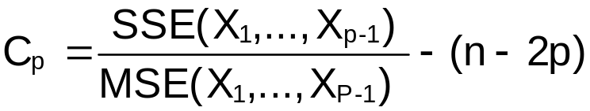
where n-2p serves as a penalty for the number of predictor variables in the model.

If X₁,…,X_{p-1} represents a “good” model, then C_{p}≈p (see #3 above). Models are also considered to be “good” if C_{p}≤p (sampling error causes C_{p} not to be p).

Notes:
- Depends on the set of P-1 variables under consideration.
- See KNN for a more in depth discussion about the derivation of C_{p}.

AIC

Maximum likelihood estimation is a procedure used to estimate model parameters given a particular distributional assumption. To fully understand it, one needs a course on mathematical statistics like STAT 463 or 883. When Y ~ N(0, σ²) in regression analysis (which we have been assuming so far), maximum likelihood estimation will yield the same estimates of β₀, …, β_{p-1} as the least squares method. Due to this equivalence, the least squares method is usually only taught in similar courses to ours. For more on maximum likelihood estimation, please see p. 27-32 in KNN and p. 315-323 in Casella and Berger (2002).

The Akaike’s Information Criterion (AIC) is a commonly used measure with maximum likelihood estimation to help select predictor variables for models. This includes the regression models discussed here and extensions discussed in many other courses like STAT 875 and 971. In general, the AIC
is:

AIC = -2log(Likelihood function evaluated at parameter
estimates) + 2∗[# of parameters in model]

The likelihood function measures how well the model fits the data (the “larger” the better). The 2∗[# of parameters in model] (= 2p for us) is a “penalty” for having too many terms in the models. The lower the value of AIC, the better the model (notice the minus sign in front of -2log(likelihood)).

Due to the equivalence of maximum likelihood estimation and the least squares method for the regression methods discussed so far, one can simplify the AIC formula to

AIC_{p} = n∗log(SSE_{p})– n∗log(n) + 2p

where SSE_{p} is the sum of squared error for the model of interest.

Other penalty values can be used than 2p. The Schwarz Bayesian Criterion (SBC) is

SBC_{p} = n∗log(SSE_{p})– n∗log(n) + log(n)∗p

SBC_{p} tend to favor models with less predictor variables when n ≥ 8 due to its penalty. The SBC is also known as the Bayesian Information Criterion (BIC).

These statistics are meaningful when they are used to compare different models. Since the same data set will be used for these different models, values like n would stay the same. Due to this fact, different software packages can provide different values of the AIC or SBC. This is due to some leaving in these “constants” in their calculations while others removing them. In the end, the software packages will still lead to the same model (provided the software calculates everything correctly!).

PRESS_{p} criterion

PRESS = PREdiction Sum of Squares

Measures the SSE obtained when the i^{th} observation is deleted.

PRESS prediction error for the i^{th} observation = Y_{i} - 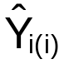

Example: Let i=3. Then PRESS prediction error =
Y₃ - 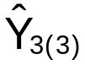. To obtain , a regression model is fit to the data where observation 3 is removed from the data set. For observation 3’s X₁,…,X_{p-1}, the predicted Y value is obtained, .

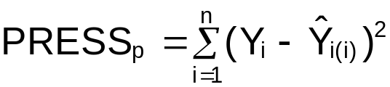

Models with a low PRESS_{p} are “good”.

Note that 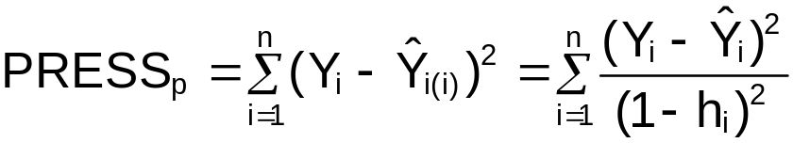 where h_{i} is the i^{th} diagonal element of the hat matrix. We will discuss why this is true in Chapter 10. For now, this provides us a convenient formula for calculating the PRESS statistic.

Notes:
- All of these model-building procedures usually will only look at the first-order terms. Step #3 of the model-building process will allow you to look for interactions and various transformations of the predictor variables. Of course, this means you still may miss a predictor variable because it is in the wrong form for the model. This is where knowledge about a data set can play an important role. You could leave a variable in the model (say MPG) even if model’s associated with it are not “good”. Later in step #3 of the model-building process, you can check for a MPG² term or some other type of transformation or interaction. If this is found to not be important, then you could remove all MPG terms from the model.
- See Section 6.5.2 in Fox (2002) for the implementation of some of these measures in R. These will also be discussed in the next section. I will discuss my own function in the example below.

Example: NBA guard data (nba_ch9.R)

Below is my own way of implementing these measures.

> nba<-read.table(file =
"C:\\chris\\UNL\\STAT870\\Chapter6\\nba_data.txt",
header=TRUE, sep = "")
> head(nba)
last.name first.initial games PPM MPG height FTP FGP age
1 Abdul-Rauf M. 80 0.5668 33.8750 185 93.5 45.0 24
2 Adams M. 69 0.4086 36.2174 178 85.6 43.9 30
3 Ainge D. 81 0.4419 26.7037 196 84.8 46.2 34
4 Anderson K. 55 0.4624 36.5455 185 77.6 43.5 23
5 Anthony G. 70 0.2719 24.2714 188 67.3 41.5 26
6 Armstrsong B.J. 81 0.3998 30.7654 188 86.1 49.9 26

> mod.fit<-lm(formula = PPM ~ MPG + height + FTP + FGP +
age, data = nba)
> sum.fit<-summary(mod.fit)
> MSE.all<-sum.fit$sigma^2

> fit.stat<-function(model, data) {
mod.fit<-lm(formula = model, data = data)
sum.fit<-summary(mod.fit)
aic.mod<-AIC(object = mod.fit, k = 2)
bic.mod<-AIC(object = mod.fit, k =
log(length(mod.fit$residuals)))
sse<-anova(mod.fit)$"Sum Sq"[
length(anova(mod.fit)$"Sum Sq")]
p<-length(mod.fit$coefficients)
n<-length(mod.fit$residuals)
Cp<-sse/MSE.all - (n-2*p)
press<-sum(mod.fit$residuals^2/
(1 - lm.influence(mod.fit)$hat)^2)
data.frame(Rsq = sum.fit$r.squared, AdjRsq =
sum.fit$adj.r.squared, AIC.stat = aic.mod,
BIC.stat = bic.mod, PRESS = press, Cp = Cp) }

I wrote my own function here to make the calculations easier. Here is the same function with the color-coded characters from WinEdt.
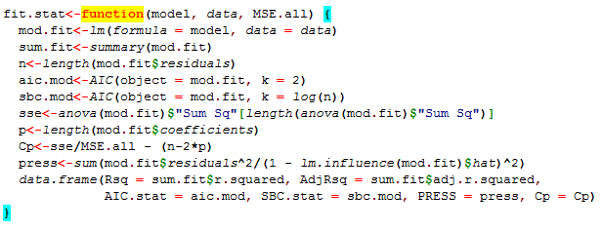
The AIC() function calculates the AIC or SBC (BIC) using the k option to specify the penalty of “2” or “log(n)” in front of p in their formulas. The lm.influence() function calculates many different diagnostic measures including the hat matrix diagonal values. This function will be discussed more in Chapter 10.

> #5 variable model
> var5<-cbind(model = 1, fit.stat(model = PPM ~ MPG +
height + FTP + FGP + age, data = nba))
> var5
model Rsq AdjRsq AIC.stat SBC.stat PRESS Cp
1 1 0.3056584 0.2705907 -179.9091 -161.3314 1.150448 6

> #4 variable model
> mod4.1<-fit.stat(model = PPM ~ MPG + height + FTP + FGP ,
data = nba, MSE.all = MSE.all)
> mod4.2<-fit.stat(model = PPM ~ MPG + height + FTP + age,
data = nba, MSE.all = MSE.all)
> mod4.3<-fit.stat(model = PPM ~ MPG + height + FGP + age,
data = nba, MSE.all = MSE.all)
> mod4.4<-fit.stat(model = PPM ~ MPG + FTP + FGP + age,
data = nba, MSE.all = MSE.all)
> mod4.5<-fit.stat(model = PPM ~ height + FTP + FGP + age,
data = nba, MSE.all = MSE.all)
> var4<-cbind(model = 1:5, rbind(mod4.1, mod4.2, mod4.3, mod4.4,
mod4.5))
> round(var4[rev(order(var4$Rsq)),],2)
model Rsq AdjRsq AIC.stat SBC.stat PRESS Cp
12 3 0.31 0.28 -181.86 -165.94 1.09 4.05
1 1 0.28 0.25 -178.63 -162.71 1.16 7.14
14 5 0.25 0.22 -174.19 -158.27 1.19 11.55
13 4 0.24 0.21 -171.94 -156.02 1.24 13.86
11 2 0.20 0.16 -166.62 -150.70 1.30 19.51

Note that the number of models per predictor variable “subset” is 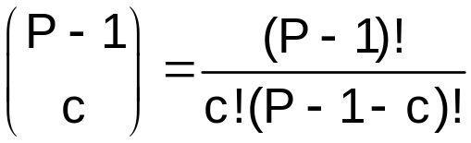 where P – 1 = number of predictor variables to choose from and c is the number of predictor variables for a subset. For example, there are 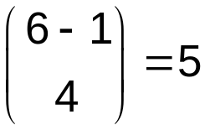 different 4 predictor variable models.

The “best” model using the R² criterion for 4 predictor variables is model #3 which corresponds to all of the variables except for FTP in the model. One should of course look at the other criterion here as well. In this case, they all agree.

I continued to do this for the 1, 2, and 3 predictor variable models. I have excluded the code implementing the function to save space. Please see the program for the actual code (this is the only way you can see what the model number corresponds to).

> var3[rev(order(var3$Rsq)),]
> round(var3[rev(order(var3$Rsq)),],2)
model Rsq AdjRsq AIC.stat BIC.stat PRESS Cp
12 3 0.28 0.26 -180.61 -167.34 1.11 5.16
18 9 0.24 0.22 -174.98 -161.71 1.15 10.79
15 6 0.24 0.21 -173.94 -160.67 1.18 11.86
16 7 0.24 0.21 -173.85 -160.58 1.19 11.96
13 4 0.22 0.20 -171.80 -158.53 1.24 14.10
11 2 0.19 0.17 -167.99 -154.72 1.24 18.21
19 10 0.18 0.16 -166.37 -153.10 1.29 20.00
1 1 0.18 0.15 -166.12 -152.85 1.30 20.28
14 5 0.14 0.12 -161.94 -148.67 1.35 25.04
17 8 0.09 0.06 -155.49 -142.22 1.43 32.78
Model 3 predictor variables: MPG, height, FGP

> round(var2[rev(order(var2$Rsq)),],2)
model Rsq AdjRsq AIC.stat BIC.stat PRESS Cp
15 6 0.23 0.22 -175.27 -164.65 1.14 10.56
12 3 0.22 0.21 -173.74 -163.12 1.18 12.17
1 1 0.18 0.16 -167.89 -157.27 1.24 18.54
19 10 0.17 0.16 -167.57 -156.96 1.24 18.89
18 9 0.17 0.15 -166.96 -156.34 1.27 19.59
11 2 0.14 0.12 -163.61 -152.99 1.29 23.43
13 4 0.13 0.11 -162.20 -151.58 1.35 25.08
14 5 0.08 0.06 -156.11 -145.50 1.41 32.48
16 7 0.05 0.03 -152.86 -142.24 1.42 36.63
17 8 0.04 0.02 -151.46 -140.84 1.48 38.45
Model 6 predictor variables: height, FGP

> round(var1[rev(order(var1$Rsq)),],2)
model Rsq AdjRsq AIC.stat BIC.stat PRESS Cp
13 4 0.17 0.16 -168.55 -160.59 1.22 18.04
1 1 0.13 0.12 -164.09 -156.13 1.28 23.20
11 2 0.05 0.04 -154.46 -146.49 1.39 35.14
12 3 0.03 0.02 -152.59 -144.63 1.45 37.58
14 5 0.00 -0.01 -149.82 -141.86 1.45 41.29
Model 4 predictor variables: FGP

Plot for :
plot(x = rep(1, times = 5), y = var1$Rsq, ylim = c(0,1), xlim
= c(1,5), type = "n", xlab = "Number of variables",
ylab = expression(R^2), main = expression(paste(R^2, "
vs. number of variables")))
text(x = rep(1, times = 5), y = var1$Rsq, labels =
var1$model, cex = 0.75)
text(x = rep(2, times = 10), y = var2$Rsq, labels =
var2$model, cex = 0.75)
text(x = rep(3, times = 10), y = var3$Rsq, labels =
var3$model, cex = 0.75)
text(x = rep(4, times = 5), y = var4$Rsq, labels =
var4$model, cex = 0.75)
text(x = 5 , y = var5$Rsq, labels =
var5$model, cex = 0.75)
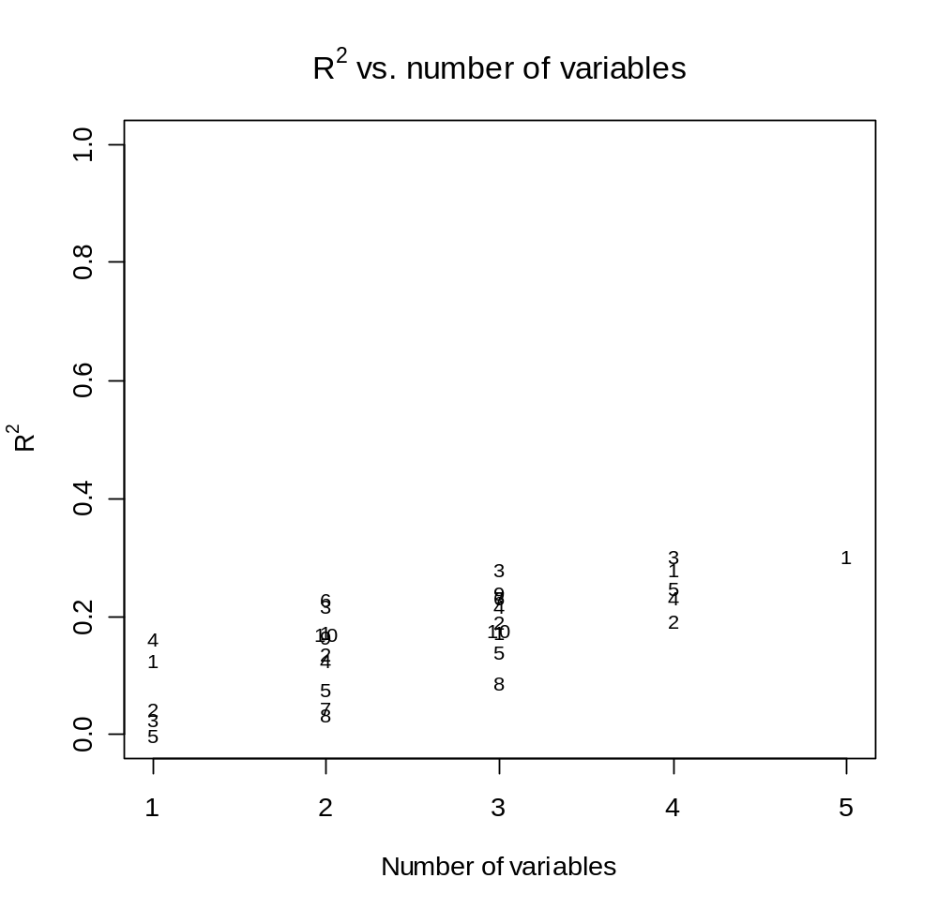
Notes:
- The data.frame’s containing the results can be sorted by measures other than !
- Using the produces the following variable sets to be considered further: MPG Height FGP, MPG Height FGP Age, and maybe MPG Height FTP FGP
- Using the produces the following variable sets to be considered further: MPG Height FGP Age (best overall due to largest value), MPG Height FGP, and maybe MPG Height FTP FGP.
- The other measures produce similar results.
- The text() function is used to plot characters on the plot.

What should you do next?

There are a number of candidate models to choose from here before moving on to step 3 of the model-building process. I would choose the model with MPG, Height, FGP, and Age predictor variables for now. However, I would also remember that the other models (and thus different predictor variables) could be important and check these out in step 3.

9.4 Automatic search procedures for model selection

When there are MANY predictor variables, fitting all possible regression models and calculating the measures discussed in Section 9.3 may not be feasible.

This section discusses search algorithms that try to find the “best” regression model.

Best subsets algorithms

Find the best models for each specific number (1, 2, …, p-1) of predictor variables. These algorithms do the searching for you using methods that may not involve actually fitting each model. Unfortunately, KNN does not specifically describe what these algorithms are so you will be responsible only for their implementation.

Example: NBA guard data (nba_ch9.R)

The leaps and car packages in R contain the needed functions to perform these methods.

> library(leaps)
> select.var<-regsubsets(x = PPM ~ MPG + height + FTP + FGP
+ age, data = nba, method = "exhaustive", nbest=4)
> select.sum<-summary(select.var, matrix.logical=TRUE)
> select.sum

Subset selection object
Call: regsubsets.formula(x = PPM ~ MPG + height + FTP + FGP + age, data = nba, method = "exhaustive", nbest = 4)
5 Variables (and intercept)
Forced in Forced out
MPG FALSE FALSE
height FALSE FALSE
FTP FALSE FALSE
FGP FALSE FALSE
age FALSE FALSE
4 subsets of each size up to 5
Selection Algorithm: exhaustive
MPG height FTP FGP age
1 ( 1 ) FALSE FALSE FALSE TRUE FALSE
1 ( 2 ) TRUE FALSE FALSE FALSE FALSE
1 ( 3 ) FALSE TRUE FALSE FALSE FALSE
1 ( 4 ) FALSE FALSE TRUE FALSE FALSE
2 ( 1 ) FALSE TRUE FALSE TRUE FALSE
2 ( 2 ) TRUE FALSE FALSE TRUE FALSE
2 ( 3 ) TRUE TRUE FALSE FALSE FALSE
2 ( 4 ) FALSE FALSE FALSE TRUE TRUE
3 ( 1 ) TRUE TRUE FALSE TRUE FALSE
3 ( 2 ) FALSE TRUE FALSE TRUE TRUE
3 ( 3 ) TRUE FALSE FALSE TRUE TRUE
3 ( 4 ) FALSE TRUE TRUE TRUE FALSE
4 ( 1 ) TRUE TRUE FALSE TRUE TRUE
4 ( 2 ) TRUE TRUE TRUE TRUE FALSE
4 ( 3 ) FALSE TRUE TRUE TRUE TRUE
4 ( 4 ) TRUE FALSE TRUE TRUE TRUE
5 ( 1 ) TRUE TRUE TRUE TRUE TRUE

Notes:
- The regsubsets() function does most of the calculations while the summary() function organizes it in a meaningful way.
- The x option in regsubsets() needs to be the complete model containing all the variables.
- The method option allows one to specify what type of search. In my case here, I chose the exhaustive option to look for all possible models. Other options are forward and backward which look for models from a specified starting location (like specify an initial model and then only look at models which remove variables for the backward method).
- The nbest option specifies how many models do you want the function to find for each number of predictor variables.
- I am not for sure how R chooses the ordering of the models. I have looked through the code and my best answer is it organizes by C_{p}. One could use the leaps() function instead of regsubsets() and choose the specific measure to organize by instead.
- The TRUE and FALSE values correspond to what predictor variables are in the models. For example, the first model has FGP only in it.

More R code and output:

> names(select.sum)
[1] "which" "rsq" "rss" "adjr2" "cp" "bic" "outmat" "obj"
> select.sum$rsq
[1] 0.16510621 0.12888891 0.04514180 0.02803542 0.23160968 0.22032686
[7] 0.17563961 0.17315989 0.28351841 0.24402771 0.23652568 0.23582944
[13] 0.30532647 0.28363472 0.25271998 0.23653073 0.30565841
> select.sum$outmat
MPG height FTP FGP age
1 ( 1 ) FALSE FALSE FALSE TRUE FALSE
1 ( 2 ) TRUE FALSE FALSE FALSE FALSE
1 ( 3 ) FALSE TRUE FALSE FALSE FALSE
1 ( 4 ) FALSE FALSE TRUE FALSE FALSE
2 ( 1 ) FALSE TRUE FALSE TRUE FALSE
2 ( 2 ) TRUE FALSE FALSE TRUE FALSE
2 ( 3 ) TRUE TRUE FALSE FALSE FALSE
2 ( 4 ) FALSE FALSE FALSE TRUE TRUE
3 ( 1 ) TRUE TRUE FALSE TRUE FALSE
3 ( 2 ) FALSE TRUE FALSE TRUE TRUE
3 ( 3 ) TRUE FALSE FALSE TRUE TRUE
3 ( 4 ) FALSE TRUE TRUE TRUE FALSE
4 ( 1 ) TRUE TRUE FALSE TRUE TRUE
4 ( 2 ) TRUE TRUE TRUE TRUE FALSE
4 ( 3 ) FALSE TRUE TRUE TRUE TRUE
4 ( 4 ) TRUE FALSE TRUE TRUE TRUE
5 ( 1 ) TRUE TRUE TRUE TRUE TRUE

Notice that you can access the R², adjusted R², C_{p}, and BIC measures through the object containing the summary() calculations. It is my understanding of the function that you can only access these values for the models displayed. Sometimes, all of these measures will not agree on what is the “best” model so this could cause problems if nbest = 1 or some other very small number (relative to the number of predictor variables) is chosen. Be careful!

Next are some plots to help organize the results.

> plot(select.var, scale="r2") #From leaps package - how
to interpret?

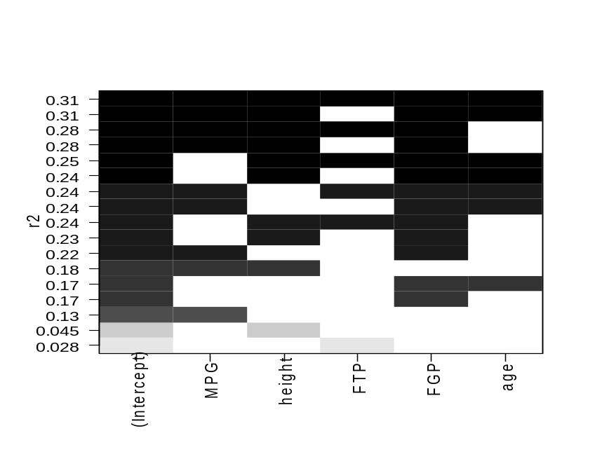
> library(car)
> win.graph(width = 6, height = 6, pointsize = 10)
> subsets(object=select.var, statistic="bic", legend=TRUE,
cex.subsets = 0.75)
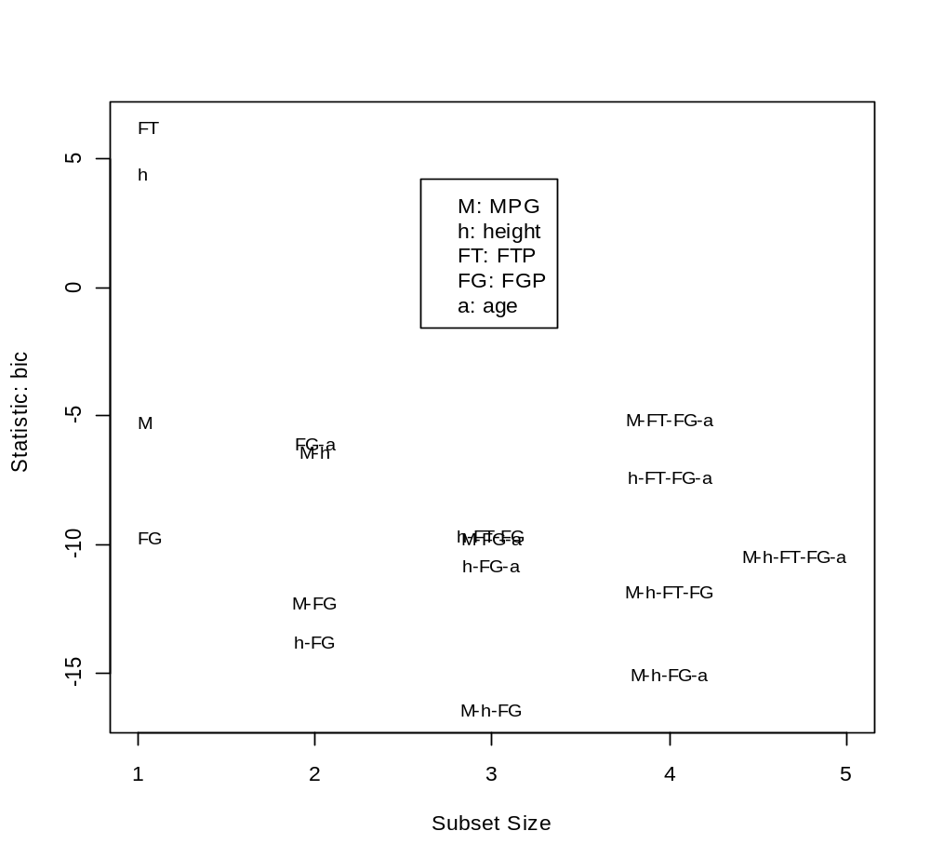
Remember that we are looking for small values for the BIC.

The subsets() function comes from the car package. Fox (2002) says that his plotting function produces a plot that is easier to interpret than the plot produced by the leaps package. I agree with him! Note that the legend is placed onto the plot by a left click on the mouse.

Additional plots:

> par(mfrow = c(2,2))
> subsets(object = select.var, statistic="rsq", legend =
FALSE, cex.subsets = 0.75)
> subsets(object = select.var, statistic="adjr2", legend =
FALSE, cex.subsets = 0.75)
> subsets(object = select.var, statistic="cp", legend =
FALSE, cex.subsets = 0.75)
> subsets(object = select.var, statistic="bic", legend =
FALSE, cex.subsets = 0.75)
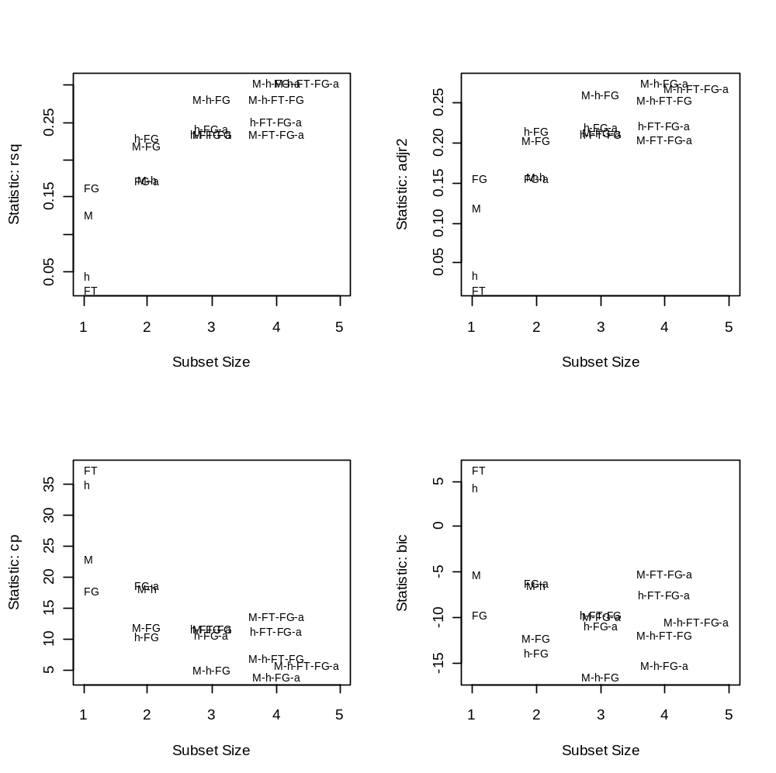

Remember that we are looking for small values close to 6 for the C_{p}.

Forward selection

Start with a model with no predictor variables.

Perform the following steps:
- Fit a simple linear regression model for each predictor variable (i.e., estimate E(Y_{i})=β₀+β₁X_{ij} for j=1,…,P-1). Pick the best model.
- Starting with the model in #1, fit all 2 predictor variable models and pick the best model which includes the variable chosen in #1. For example, suppose the model E(Y_{i})=β₀+β₁X_{i3} was chosen in #1. Then all 2 variable models that include X₃ are fit.
- Starting with the model in #2 fit all 3 predictor variable models and pick the best model which includes the variables chosen in #1 and #2.

The procedure stops when no more variables are important enough to add to the model.

Notes:
- There are a variety of criteria that could be used here to pick models. The most often used is a hypothesis test (t-test, partial F-test) to determine if a predictor variable should be added to the model. In this case,
H₀: Model found from previous step
H_{a}: Model with new variable

Equivalently,

H₀: Reduced model
H_{a}: Complete model

If a p-value is small for this test, then the corresponding predictor variable is important. The predictor variable with the smallest p-value corresponds to the variable to add to the model. Remember that all indicator variables for a qualitative variable NEED to be tested together! The procedure stops when the p-values for predictor variables not included yet are all greater than some pre-specified α. A recommended level of significance to use is α=0.15. This helps to ensure all possibly important variables are allowed to enter the model. In step 3 of the model-building process, we can remove some of the marginally significant variables if needed. For now, we are just looking for a good model to proceed on to step 3 with.

- The AIC and BIC are also commonly used to decide what variables are important. In this case, the predictor variable with the lowest AIC or BIC at a stage of the process correspond to the variable to add. Once the AIC or BIC stop getting smaller, the forward selection process ends.

Backward elimination

Start with all of the predictor variables in the model.

Perform the following steps:
- Fit the model with all of the predictor variables in the model. Remove the variable that is least important (not helpful for predicting the response variable).
- Starting with the model in #1, remove the variable that is least important.

The procedure stops when all of the remaining model variables are important.

Notes:
- Again, hypothesis tests can be used to decide on what variables are important. A

H₀: Reduced model
H_{a}: Complete model

hypothesis test is still used. When looking for variables to remove then, one is looking for “large” p-values. The variable with the largest p-value is removed from the model. The procedure stops when the p-values corresponding to terms in the model are all less than some pre-specified α. A recommended level of significance to use is α=0.30. This helps to ensure that no possibly important variables are removed model. In step 3 of the model-building process, we can remove some of the marginally significant variables if needed. For now, we are just looking for a good model to proceed on to step 3 with.

- Also, the AIC and BIC can be used in the same type of manner. The variables are removed one at a time corresponding to the AIC or BIC that is the smallest than the current model. Once the AIC or BIC stop getting smaller, backward elimination ends.

Stepwise forward selection

Combination of forward selection and backward elimination.

Start with a model with no predictor variables.

Perform the following steps:
- Fit a simple linear regression model for each predictor variable. Pick the best model.
- Starting with the model in #1, fit all 2 predictor variable models and pick the best model which include the variable chosen in #1.
- After adding the variable, determine if any predictor variables should be removed.
- Using the resulting model in #3, determine if any variables should be added.


Notes:
- Hypothesis tests, AIC, and BIC can be used here.
- The procedure stops when no more variables can be added or removed.
- A recommended level of significance to use with hypothesis tests is α=0.15 for adding and α=0.30 for removal.

Note that these model selection procedures do not always end up with the same model! Also, personal knowledge of a particular data problem should be used here. For example, if one knows that MPG² is important (suppose it was), but MPG is removed from the model using these model selection procedures (before MPG² was considered), it does not hurt to put it in the model and proceed on to step 3 of the model building process. In step 3, there will be an opportunity to remove it if it is found to still not be worthwhile to include.

Example: NBA guard data (nba_ch9.R)

Perform forward selection, backward elimination, and stepwise selection.

Forward:
> #Need to fit a model first - choose the model
corresponding to the lower bound
> mod.fit.for<-lm(formula = PPM ~ 1, data = nba) #Model with
just intercept
> step.for<-step(object = mod.fit.for, direction = "forward",
scope=list(lower = PPM ~ 1, upper = PPM ~
MPG + height + FTP + FGP + age),
k = 2) #use k = log(n) for BIC)
Start: AIC= -451.58
PPM ~ 1
Since FGP results in the smallest AIC that is smaller than the intercept only model, it is added to the model.
Df Sum of Sq RSS AIC
+ FGP 1 0.23 1.17 -468.53
+ MPG 1 0.18 1.22 -464.07
+ height 1 0.06 1.33 -454.43
+ FTP 1 0.04 1.36 -452.57
<none> 1.40 -451.58
+ age 1 0.00285 1.39 -449.80

Step: AIC= -468.53
PPM ~ FGP
Since height results in the smallest AIC that is smaller than the intercept and FGP model, it is added to the model.
Df Sum of Sq RSS AIC
+ height 1 0.09 1.07 -475.25
+ MPG 1 0.08 1.09 -473.72
<none> 1.17 -468.53
+ age 1 0.01 1.15 -467.55
+ FTP 1 0.004457 1.16 -466.93

Step: AIC= -475.25
PPM ~ FGP + height

Df Sum of Sq RSS AIC
+ MPG 1 0.07 1.00 -480.59
<none> 1.07 -475.25
+ age 1 0.02 1.06 -474.96
+ FTP 1 0.01 1.07 -473.82

Step: AIC= -480.59
PPM ~ FGP + height + MPG

Df Sum of Sq RSS AIC
+ age 1 0.03 0.97 -481.84
<none> 1.00 -480.59
+ FTP 1 0.0001624 1.00 -478.61

Step: AIC= -481.84
PPM ~ FGP + height + MPG + age

Df Sum of Sq RSS AIC
<none> 0.97 -481.84
+ FTP 1 0.0004636 0.97 -479.89

> step.for #Returns b's

Call:
lm(formula = PPM ~ FGP + height + MPG + age, data = nba)

Coefficients:
(Intercept) FGP height MPG age
-0.764257 0.009520 0.004337 0.003132 -0.005188

> #Summary
> step.for$anova
Step Df Deviance Resid. Df Resid. Dev AIC
1 NA NA 104 1.396712 -451.5831
2 + FGP -1 0.23060588 103 1.166106 -468.5304
3 + height -1 0.09288622 102 1.073220 -475.2461
4 + MPG -1 0.07250157 101 1.000719 -480.5904
5 + age -1 0.03045958 100 0.970259 -481.8360

R chooses the model with FGP, height, MPG, and age through forward selection. Notice that adding FTP makes the AIC value increase so it is not added to the model.

Backward:
> #Need to fit a model first - choose the model
corresponding to the upper bound
> mod.fit.back<-lm(formula = PPM ~ MPG + height + FTP + FGP
+ age, data = nba)
> step.back<-step(object = mod.fit.back, direction =
"backward", scope=list(lower = PPM ~ 1, upper = PPM ~
MPG + height + FTP + FGP + age), k = 2) #use k =
log(n) for BIC)
Start: AIC= -479.89
PPM ~ MPG + height + FTP + FGP + age

Df Sum of Sq RSS AIC
- FTP 1 0.0004636 0.97 -481.84
<none> 0.97 -479.89
- age 1 0.03 1.00 -478.61
- MPG 1 0.07 1.04 -474.17
- height 1 0.10 1.07 -471.92
- FGP 1 0.15 1.12 -466.60

Step: AIC= -481.84
PPM ~ MPG + height + FGP + age

Df Sum of Sq RSS AIC
<none> 0.97 -481.84
- age 1 0.03 1.00 -480.59
- MPG 1 0.09 1.06 -474.96
- height 1 0.10 1.07 -473.92
- FGP 1 0.16 1.13 -467.97

> #Summary
> step.back$anova
Step Df Deviance Resid. Df Resid. Dev AIC
1 NA NA 99 0.9697955 -479.8862
2 - FTP 1 0.0004636281 100 0.9702591 -481.8360

R chooses the model again with FGP, height, MPG, and age through backward selection. Notice that the model without FTP was the only model that would decrease the AIC when compared to the model with all variables in it. When other variables are removed from this 4 variable model, the AIC would increase.

Forward stepwise:
> mod.fit.for<-lm(formula = PPM ~ 1, data = nba)
> step.for<-step(object = mod.fit.for, direction = "both",
scope=list(lower = PPM ~ 1, upper = PPM ~
MPG + height + FTP + FGP + age),
k = 2, trace = 0)

> step.for$anova
Step Df Deviance Resid. Df Resid. Dev AIC
1 NA NA 104 1.396712 -451.5831
2 + FGP -1 0.23060588 103 1.166106 -468.5304
3 + height -1 0.09288622 102 1.073220 -475.2461
4 + MPG -1 0.07250157 101 1.000719 -480.5904
5 + age -1 0.03045958 100 0.970259 -481.8360

The trace = 0 option turns off the printing from the step() function. Forward stepwise selection selects the same model. No variables are removed once they are in the model.

Using hypothesis tests is more difficult to do in R because there are no specific functions available to do it. Note that many other statistical packages do have this available. Here is how one could do it in R.

> test.var<-function(Ho, Ha, data) {
Ho.mod<-lm(formula = Ho, data = data)
Ha.mod<-lm(formula = Ha, data = data)
anova.fit<-anova(Ho.mod, Ha.mod)
round(anova.fit$"Pr(>F)"[2], 4)
}

> #############################################################
> # Forward

> MPG<- test.var(Ho = PPM ~ 1, Ha = PPM ~ MPG, data = nba)
> height<-test.var(Ho = PPM ~ 1, Ha = PPM ~ height, data = nba)
> FTP<- test.var(Ho = PPM ~ 1, Ha = PPM ~ FTP, data = nba)
> FGP<- test.var(Ho = PPM ~ 1, Ha = PPM ~ FGP, data = nba)
> age<- test.var(Ho = PPM ~ 1, Ha = PPM ~ age, data = nba)
> data.frame(MPG, height, FTP, FGP, age)
MPG height FTP FGP age
1 2e-04 0.0296 0.0878 0 0.6473

> #ADDED FGP
> MPG<- test.var(Ho = PPM ~ FGP, Ha = PPM ~ FGP + MPG, data = nba)
> height<-test.var(Ho = PPM ~ FGP, Ha = PPM ~ FGP + height, data=nba)
> FTP<- test.var(Ho = PPM ~ FGP, Ha = PPM ~ FGP + FTP, data = nba)
> age<- test.var(Ho = PPM ~ FGP, Ha = PPM ~ FGP + age, data = nba)
> data.frame(MPG, height, FTP, age)
MPG height FTP age
1 0.0084 0.0037 0.533 0.3212

> #ADDED height
> MPG<- test.var(Ho = PPM ~ FGP + height, Ha = PPM ~ FGP + height + MPG,
data = nba)
> FTP<- test.var(Ho = PPM ~ FGP + height, Ha = PPM ~ FGP + height + FTP,
data = nba)
> age<- test.var(Ho = PPM ~ FGP + height, Ha = PPM ~ FGP + height + age,
data = nba)
> data.frame(MPG, FTP, age)
MPG FTP age
1 0.008 0.4569 0.2007

> #ADDED MPG
> FTP<- test.var(Ho = PPM ~ FGP + height + MPG,
Ha = PPM ~ FGP + height + MPG + FTP, data =
nba)
> age<- test.var(Ho = PPM ~ FGP + height + MPG,
Ha = PPM ~ FGP + height + MPG + age, data =
nba)
> data.frame(FTP, age)
FTP age
1 0.8989 0.0795

> #ADDED age
> FTP<- test.var(Ho = PPM ~ FGP + height + MPG + age,
Ha = PPM ~ FGP + height + MPG + age + FTP,
data = nba)
> FTP
[1] 0.8282
To summarize,
 | Variable added | P-value
1 | FGP | 0
2 | height | 0.0037
3 | MPG | 0.0080
4 | age | 0.0795

Notice that my function test.var(), will also handle qualitative variables in a factor format.

> #####################################################
> # Backward
> MPG<- test.var(Ho = PPM ~ height + FTP + FGP + age,
Ha = PPM ~ MPG + height + FTP + FGP + age,
data = nba)
> height<-test.var(Ho = PPM ~ MPG + FTP + FGP + age,
Ha = PPM ~ MPG + height + FTP + FGP + age,
data = nba)
> FTP<- test.var(Ho = PPM ~ MPG + height + FGP + age,
Ha = PPM ~ MPG + height + FTP + FGP + age,
data = nba)
> FGP<- test.var(Ho = PPM ~ MPG + height + FTP + age,
Ha = PPM ~ MPG + height + FTP + FGP + age,
data = nba)
> age<- test.var(Ho = PPM ~ MPG + height + FTP + FGP ,
Ha = PPM ~ MPG + height + FTP + FGP + age,
data = nba)
> data.frame(MPG, height, FTP, FGP, age)
MPG height FTP FGP age
1 0.0071 0.0022 0.8282 2e-04 0.0795

> #REMOVED FTP
> MPG<- test.var(Ho = PPM ~ height + FGP + age,
Ha = PPM ~ MPG + height + FGP + age, data =
nba)
> height<-test.var(Ho = PPM ~ MPG + FGP + age,
Ha = PPM ~ MPG + height + FGP + age, data =
nba)
> FGP<- test.var(Ho = PPM ~ MPG + height + age,
Ha = PPM ~ MPG + height + FGP + age, data =
nba)
> age<- test.var(Ho = PPM ~ MPG + height + FGP ,
Ha = PPM ~ MPG + height + FGP + age, data =
nba)
> data.frame(MPG, height, FGP, age)
MPG height FGP age
1 0.0037 0.0022 1e-04 0.0795

To summarize,
 | Variable removed | P-value
1 | FTP | 0.8282

Perform forward stepwise on your own.

Note that all procedures result in the variables MPG, Height, Age, and FGP. This will not always occur!

Now, model refinement and selection procedures begin. This involves examining diagnostics, determining if interactions or quadratic terms should be added to the model,…

9.5 Some final comments on automatic model selection procedures

Read!

9.6 Model validation

The final step in the model building process is validation of the selected regression model.

Why does KNN put this section here if it is the “final step” and we still need to go over step #3 thoroughly? This section used to be after all of Chapter 10, which probably is its better place! We will discuss it then.

